Welcome to the official user guide for the Western Pennsylvania Hockey League (WPHL), or the newly created BSHL! Whether you are a passionate hockey fan or a recent recruit to our exciting simulation league, this guide is designed to help you navigate through the thrilling world of the WPHL/BSHL. From understanding the rules and regulations, to building your dream team, we’ve got you covered. Get ready to immerse yourself in the action-packed world of simulation ice hockey!
About the WPHL
The WPHL was founded in December of 2014 by Mike Chontos. The league was initially populated with a group of 6 close friends from Pittsburgh, PA. Mike was sent to Afghanistan in January of 2015, but that didn’t stop him from beginning to simulate season 1. Ever since we have started to collect a really good group of GMs that have stuck around for 7+ years. We simulate 2 seasons a calendar year to keep the downtime to a minimum. Our league uses the STHS simulator and is based off of real NHL performance. Ratings are gathered for the players using complex equations that are based mostly on the most recent NHL season. For example, 2 and 3 used statistics gathered from the 2014-15 NHL season.
League Schedule
Since we run 2 seasons a year, we have a general idea of when certain events will take place. This is not always concrete, but below is a guideline of what you can expect.
Odd Seasons (1,3,5,etc) begin February 5th.
The regular season is approximately 123 days and ends early June.
Playoffs begin in June, typically end early July.
NHL real-life draft is typically end of June, ours is 1 week later.
Off-season is July-August and consists of presigns, prospect activations, and free agency
Even Seasons (2,4,6,etc) begin August 20th.
The regular season is approximately 123 days and ends mid-December
Playoffs begin mid-Decemeber, typically end early January
Offseason begins with presigns, prospect activations, and free agency.
Repeat! Please note that these dates are approximate and can be adjusted to fit specific needs for the current season.

New GM To-Do List
Visit the website at https://wphlhockeysim.club
Click the image below to take you to the current season. This is where you can scout what team you would like to take over and their current situation.

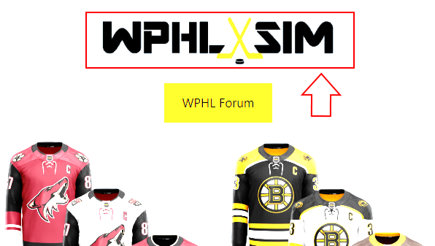
This will take you to what is referred to as the index page. On here, you can see what teams are currently without a GM (in red) and the link to any specific team can be found at the top (in blue)
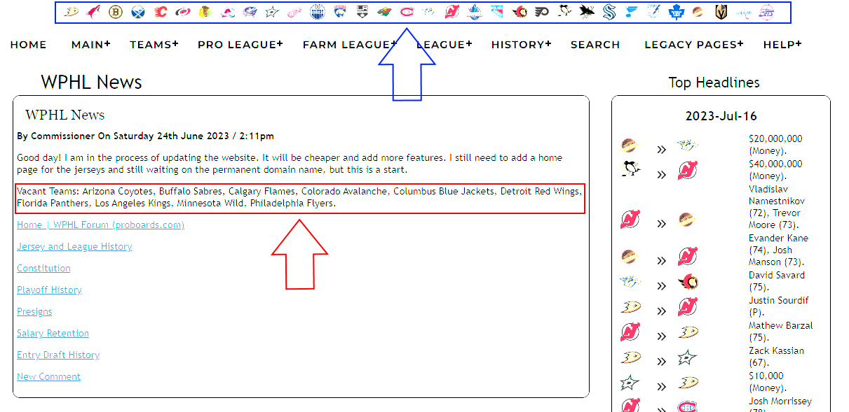
Once you click a team you are interested in (or are the GM of), the team home page will show up. From here, you can look at the roster, player info which includes age and contract information and current salary, depth (which shows prospects) and finance. Click on roster to show every player and their current ratings.
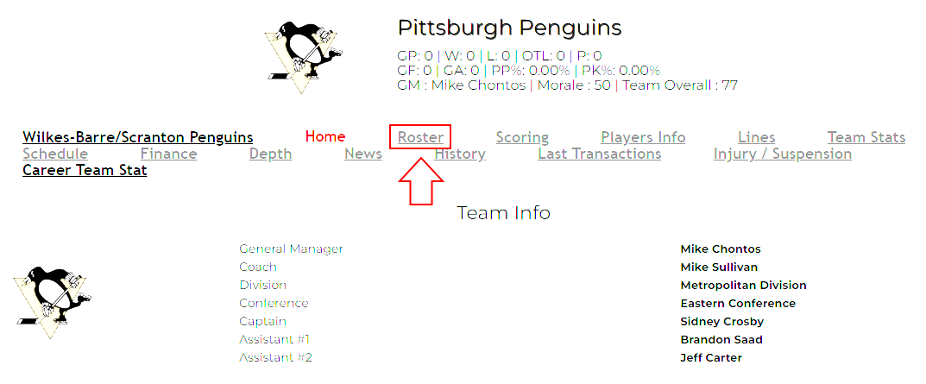
Ratings are as follows:
Checking (CK) - The higher the stat, more hit he'll give.
Fighting (FG) - The higher the stat, more fight he'll be part of.
Discipline (DI) - The higher the stat, less penalty he'll take.
Skating (SK) - The higher the stat, less chance to get successfully hit.
Strength (ST) - The higher the stat, less chance to get successfully hit. Limited effect on faceoff.
Endurance (EN) - Affect all games stats. If a player's is send on ice when he's fatigue, this stat is used in the formula to decide if all stats for this shift will be lower than normal. Also uses in the post-game fatigue formula.
Durability (DU) - The higher the stat, less chance to get injure.
Puck Handling (PH) - The higher the stat, less chance to get successfully hit / less chance to lost control of puck / better chance in shot block or shot deflection.
Face Offs (FO) - The higher the stat, the more faceoff he'll win.
Passing (PA) - The higher the stat, better chance to have a successful pass.
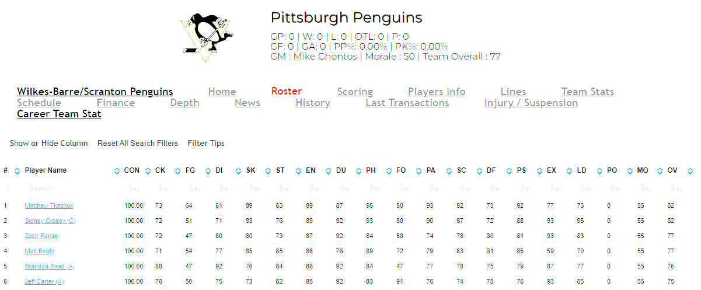
Scoring (SC) - The higher the stat, better chance to score by normal shot or deflection.
Defense - The higher the stat, better he'll play in defense / he'll block more shot / he'll retrieved more free puck.
Penalty Shot (PS) - The higher the stat, the more chance to score in a penalty shot.
Experience (EX) - The higher the stat, the better his morale and his team morale will be. Limited effect on faceoff.
Leadership (LD) - The higher the stat, the better his morale and his team morale will be.
Morale (MO) - Affect all game stats at beginning of game. The higher the stat, the higher the players performance boost will be. (It's combined with the Team Morale)
Potential (PO) - Only used in the STHS Rerate Formula (We do not use)
All of these categories can be sorted by simply clicking on it.
From the main team page, navigate to “Depth”.
On this screen, if you scroll to the bottom, you are able to see all of that teams prospects.
You will also see a section for draft picks, however WE DO NOT USE THIS. Draft picks are tracked through the forum since we simulate 2 seasons a calendar year.
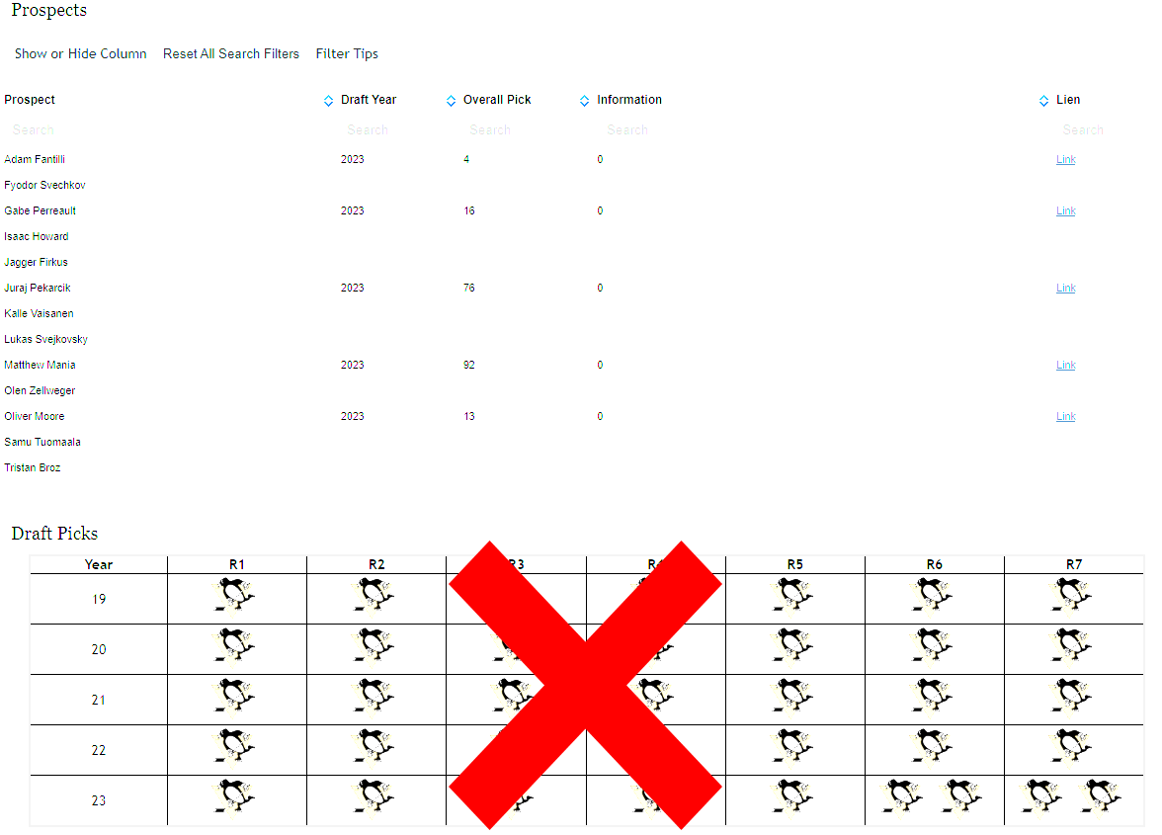
Once you have decided on a team, send an email to mike.chontos@yahoo.com with the intent on joining. One approved, head back to the main website at https://wphlhockeysim.club
Click on WPHL Forum
From here, create an account and wait to be approved.
Once approved, you can navigate down to Future Draft Picks to see what picks your team owns.
Here you can see what picks you own for the next 4 entry drafts. Washington GM updates these regularly after trades, and a new year is added shortly after the entry draft.
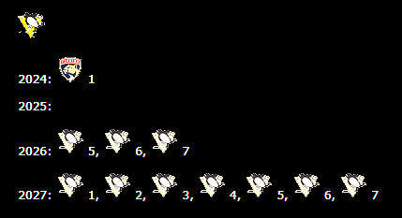
After this, PLEASE INTRODUCE YOURSELF TO THE OTHER GMS AT Introduce Yourself | WPHL Forum (proboards.com)
League Constitution
Now that you are familiar with your team, please review the league’s constitution at https://indd.adobe.com/view/46699687-d9a7-439a-8012-b6c40ae90f52
This shares a brief history of the league and includes information such as GM duties, Roster requirements, waivers, prospects, how to trade, releasing players, money, the entry draft and lottery, rerates, press releases, award money, penalties, presigns, free agency, salary retention, and jersey selection.
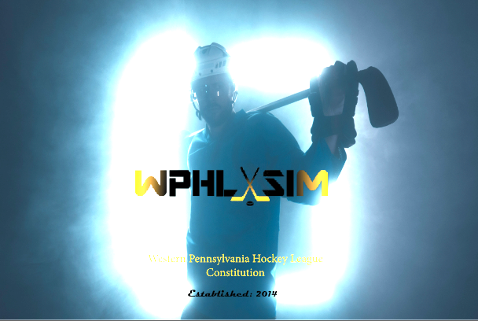
League Discord
On the forum, click League Announcements. There is a topic called “Discord”. Clicking that will show the link for you to join our discord server! This is how we make our picks in the entry draft and also BS from time to time.
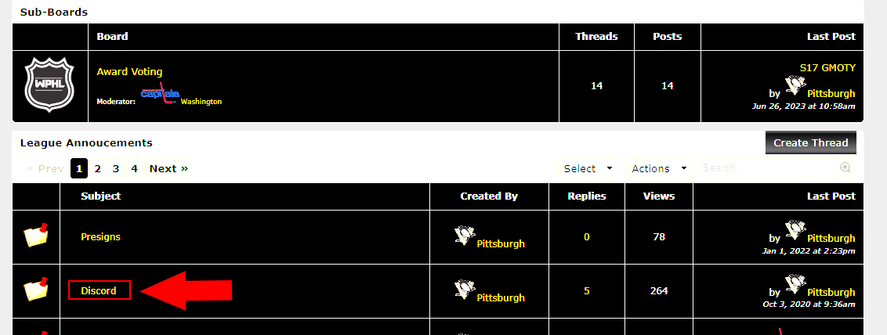

Editing Team Lines and Rosters
New to the website is the web editor where you can edit your teams lines on the go. You no longer need to download the STHS client to do this. The first step is to email mike.chontos@yahoo.com and choose a password for your team. After this is set up, head to the index page and click login.
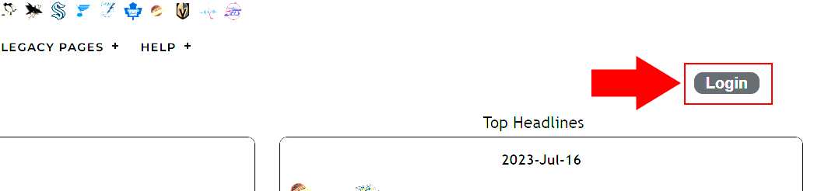
Click the dropdown box and select your team and insert your password. Click login.
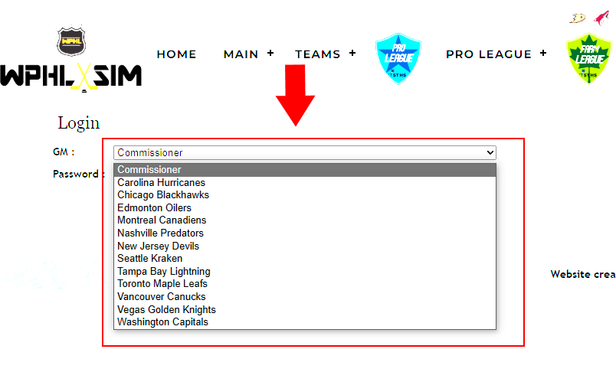
Once logged on, hover over main and select Web Client
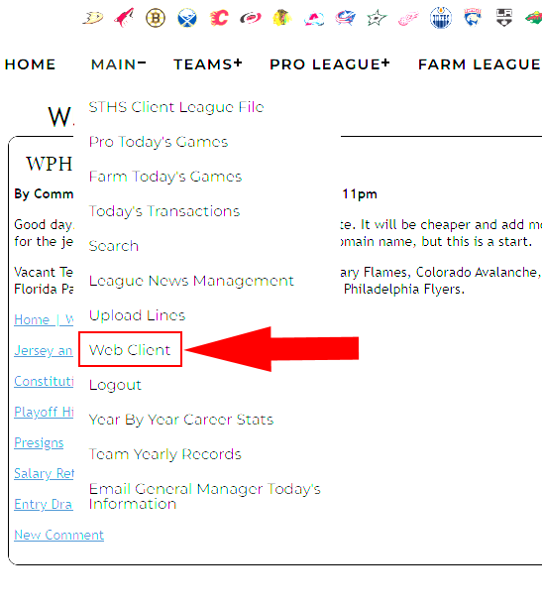
You can click edit roster to assign players to pro or farm team. Click edit lines to bring you to the following screen:
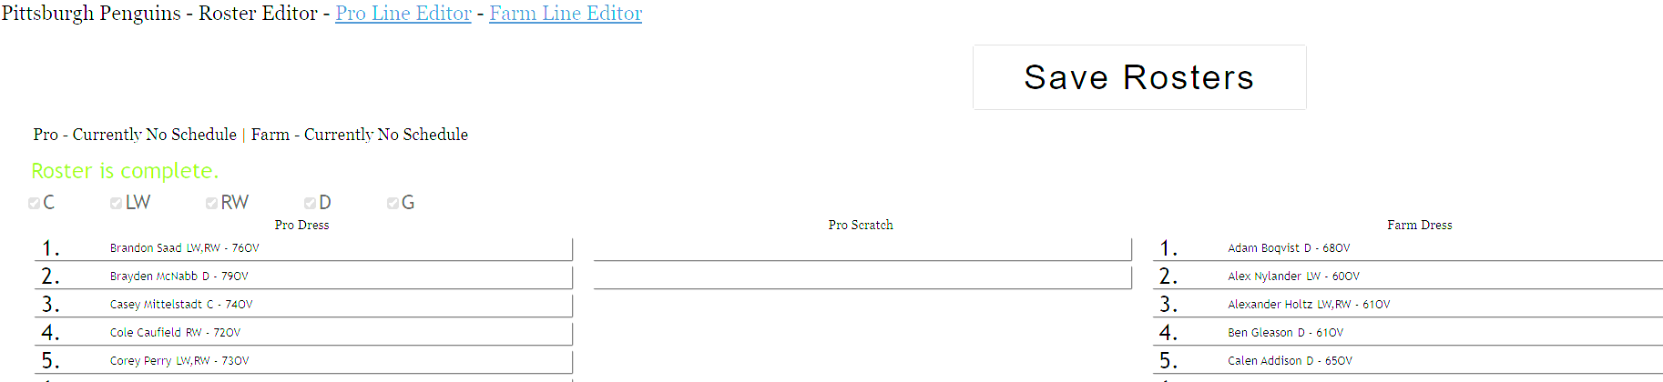
From this screen you can drag and drop players to pro or farm. MAKE SURE TO CLICK SAVE ONCE YOU ARE DONE.
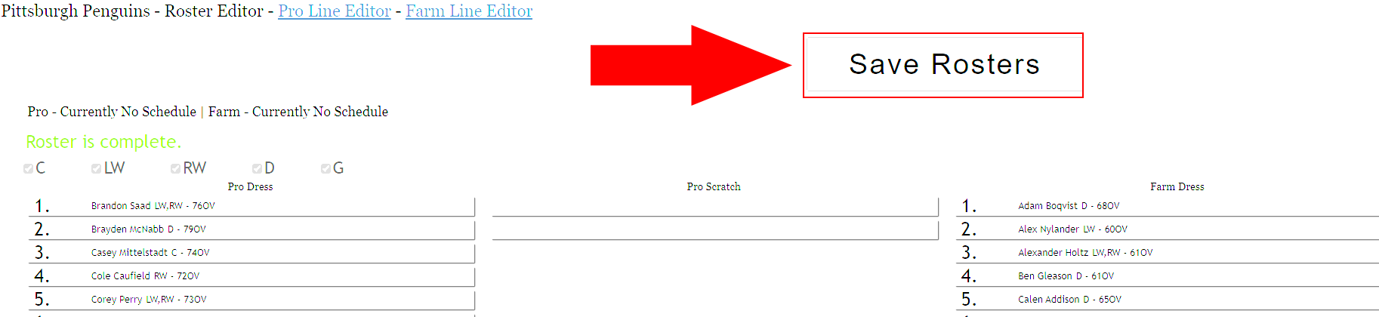
From here, click Pro Line Editor
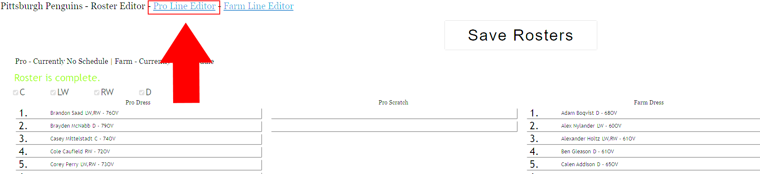
On the line editor, it will tell you what lines are incorrect. It will not let you save unless everything is corrected. Make sure to SAVE ROSTERS once you are done editing. Here you can move players to whatever line you want. There are tabs for Forward, Defense, PP, PK, etc. You can also select the play style for each line: Physical, Offensive, Defensive. This number must add up to 5.
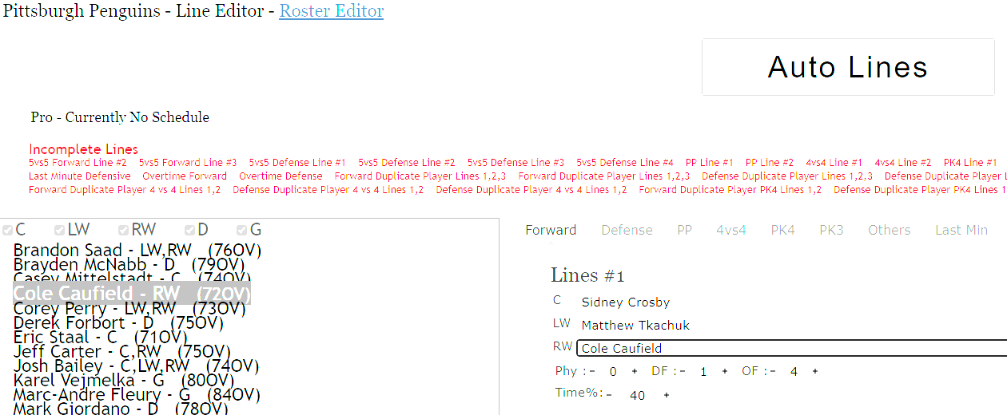

If you decide to use the client, a guide can be found here: STHS Client Guide (adobe.com)
Advanced Features
Heading back to the index page, you can see under WPHL News there are various links.
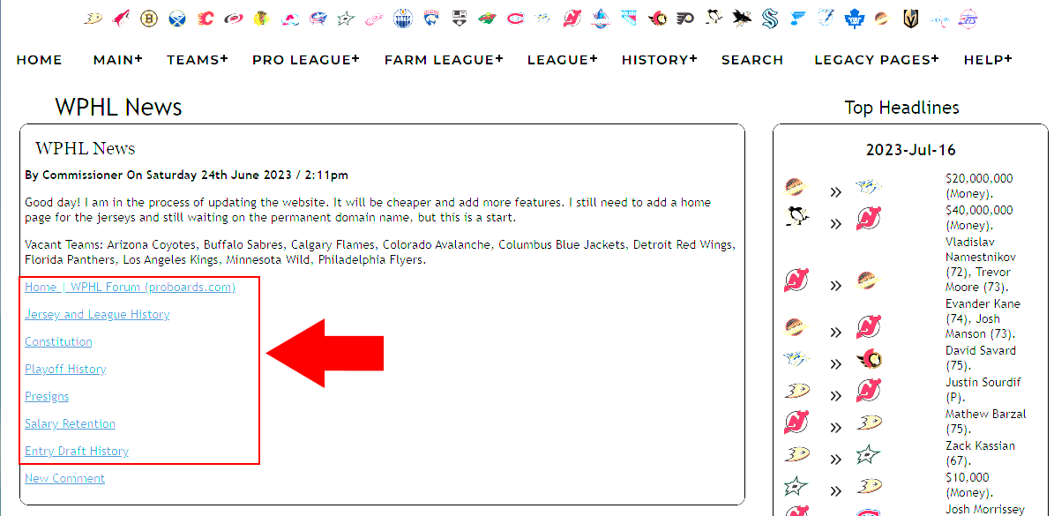
The forum you are familiar with.
The next link is
Jersey and League History
. Clicking on this will bring you to a document that tracks jersey history, GM history, Season Openers, Award Winners, Banners, Cup Finals, Players that have won a cup, and Winter Classics.
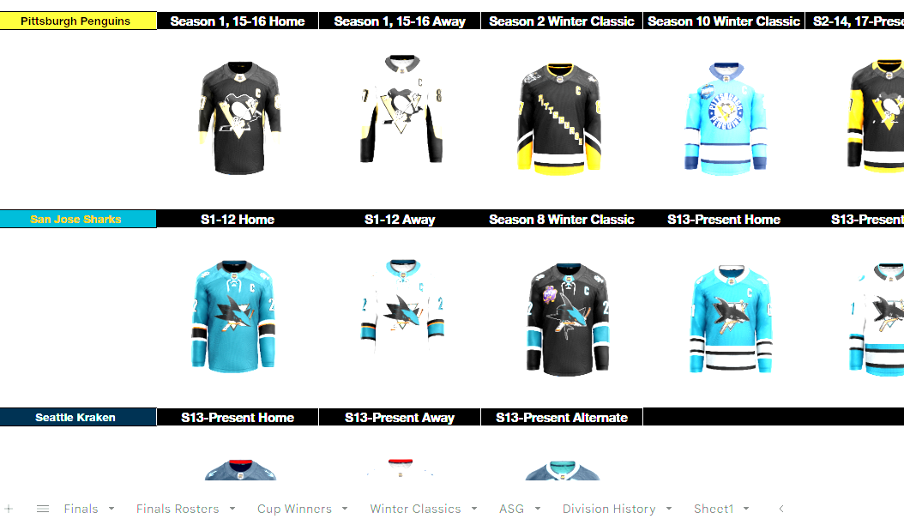
The constitution you are also familiar with.
Playoff History
will take you to a document that shows all past season playoff brackets and champions, as well as all time playoff wins.
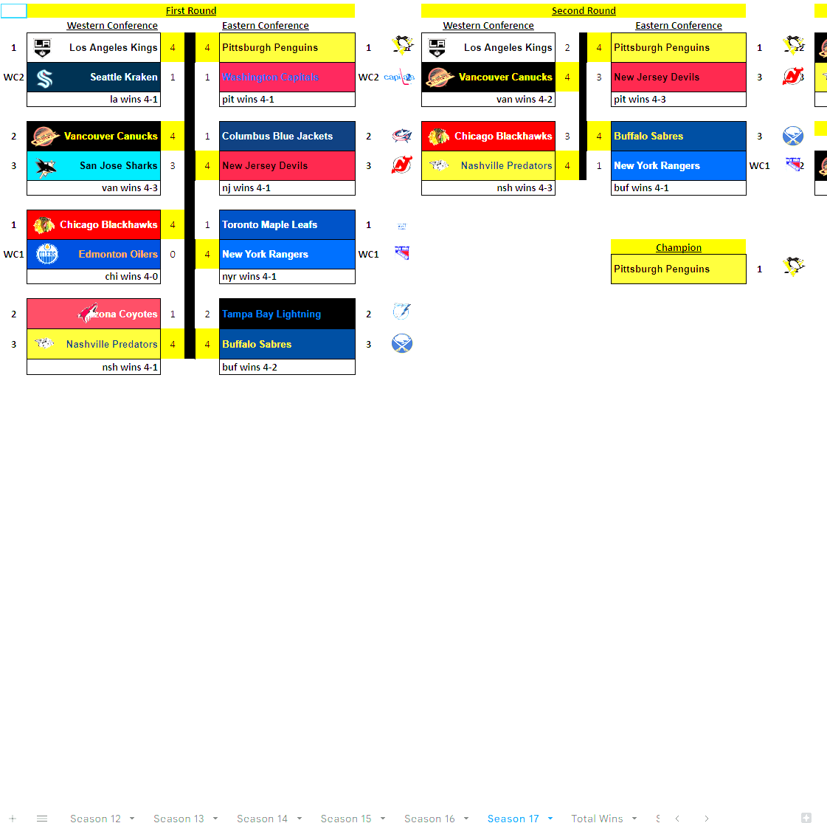

Presigns
will take you to a spreadsheet that shows a history of who was presigned and how many you have left to use for the current season. A detailed explanation of this can be found in the constitution. When conducting presigns, please reference capfriendly.
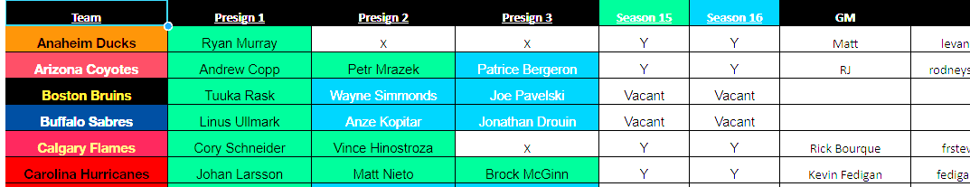
Salary Retention
will bring you to a document that shows all teams and the players they are currently retaining salary on and how many more seasons are left on the retention.
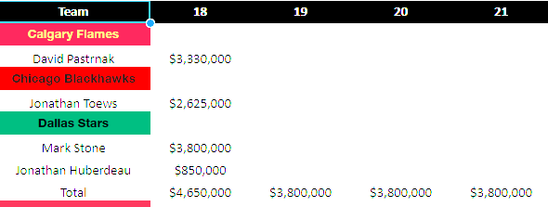
And finally
Entry Draft History
will show every entry draft we’ve had and the selections made.
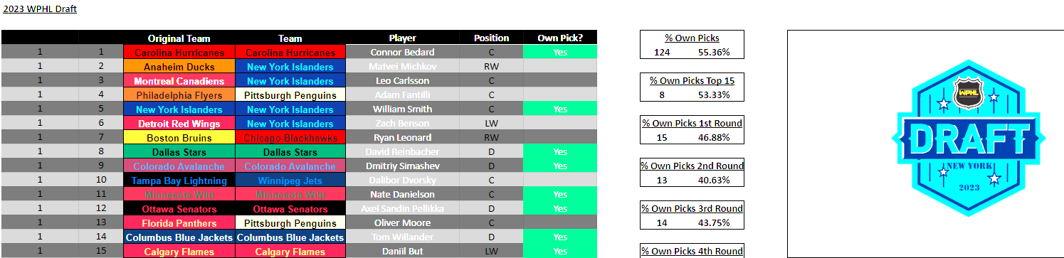

Other Useful Links
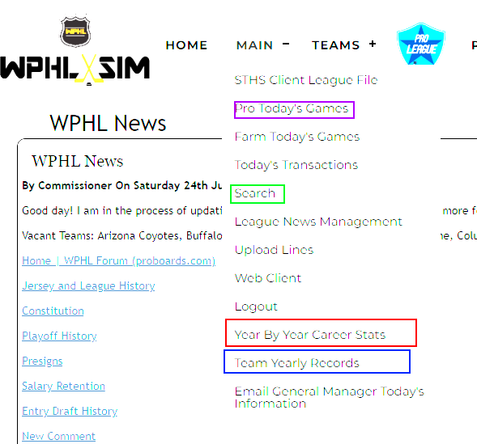
(Purple) Pro Today’s Games will show box scores for that day’s simulation. You can click each one for an in-depth look at the game.
(Green) Search function is very useful. If you click this, then click submit under Players Roster Menu, you can see every player in the league and what team they belong to. Can filter based on your input.
(Red) Will show year by year stats for every player. Again can filter based on your input.
(Blue) Will show every teams record for every season.
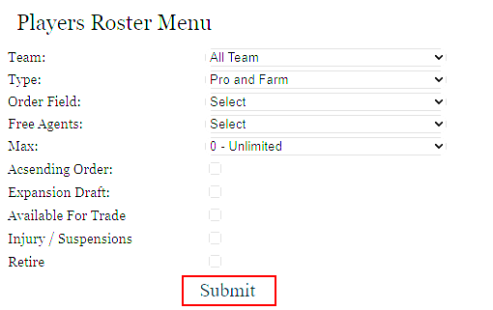
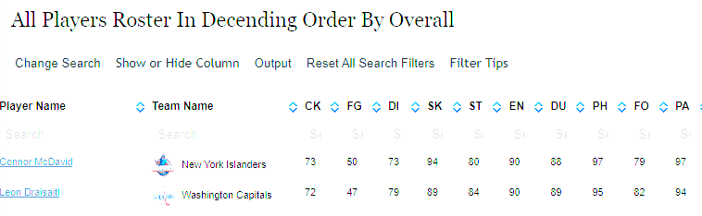
Career Stats
Hovering over History will allow you to view stanley cup winners (Only for S17 and onward), Career stats for all players and goalies.
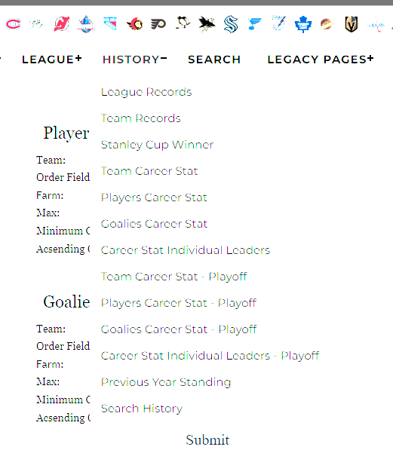

Season Snapshots
And finally, back on https://wphlhockeysim.club, if you scroll down the page, you will come across banners from all of the previous seasons. You can click on the links under the banners to get a snapshot of the end of each regular season and playoffs. Starting with Season 17, all information can be found on the non-HTML link.
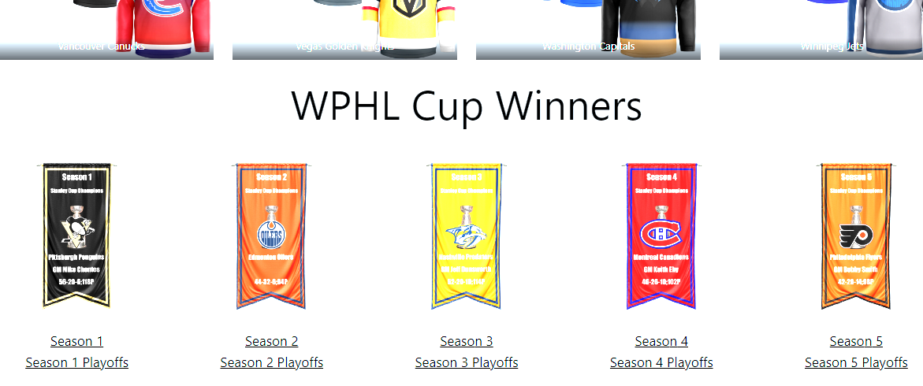
WPHL Trading Trends
In our simulation hockey league, we consider first round picks from any year as highly valuable assets due to their potential to bring in top-tier talent. Additionally, prospects recently drafted in the first, and occasionally second, rounds are seen as valuable investments as they possess promising skills and potential for growth. NHL regulars under 24 are highly sought after due to their youth, consistent performance, and the opportunity for long-term contributions to a team's success. Finally, the league recognizes the immense value of superstars and elite/high-end players aged 24-28, as they bring a combination of experience, skill, and prime performance to their respective teams.
As always, any GM can be contacted and we would be more than happy to assist you. It can be difficult to get going, but once you do you will stick around for a lifetime. Thank you!

